|  |  |  |  |  |
| --- | --- | --- | --- | --- |
| INGLES | ESPAÑOL |  |  |  |
| Think | Pensar |  |  |  |
| Will learn | Aprenderá |  |  |  |
| See | ver | Sees | verá |  |
| You leave | Te vas | She leaves | Ella se va |  |
| Wake | Despertarse |  |  |  |
| Try | Inténtalo |  |  |  |
| At | A la |  |  |  |
| Are | son | Are (Plural) | Is (Singular) |  |
| Now | Ahora |  |  |  |
| Goes | va |  |  |  |
| Choose | Escoger |  |  |  |
| Match | Unir | Partido |  |  |
| To be | Ser o Estar |  |  |  |

|  |  |  |  |  |
| --- | --- | --- | --- | --- |
| INGLES | ESPAÑOL |  |  |  |
| Waiter | Garzón |  |  |  |
| Very expensive | Muy costoso |  |  |  |
| Fix | arreglar |  |  |  |
| Somethings | Algunas cosas |  |  |  |
| Borrow+ | Pedir prestado |  |  |  |
| Has | posee |  |  |  |
| Should | debería |  |  |  |

|  |  |  |  |  |
| --- | --- | --- | --- | --- |
| INGLES | ESPAÑOL |  |  |  |
| Which | Cual |  |  |  |
| Will | Hablar en futuro |  |  |  |
| Only | Solo |  |  |  |
| Way | Forma |  |  |  |
| Want | Quiero | Need | Necesito | [WANT/NEED + TO + VERB] |
| Dinner | Cena |  |  |  |
|  |  |  |  |  |

|  |  |  |  |  |
| --- | --- | --- | --- | --- |
| INGLES | ESPAÑOL |  |  |  |
| We | Nosotros(a) |  |  |  |
| She | Ella |  |  |  |
| he | El |  |  |  |
| I am | Soy |  |  |  |
| They | Ellos |  |  |  |
| his | Su |  |  |  |
|  |  |  |  |  |

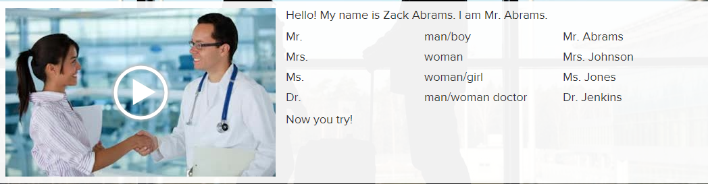

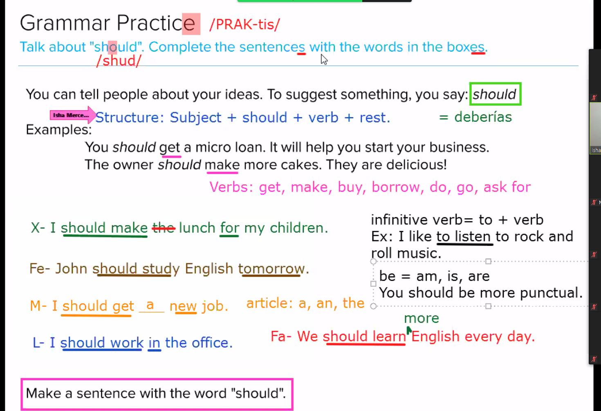

|  |  |  |  |  |
| --- | --- | --- | --- | --- |
| INGLES | ESPAÑOL |  | HORA EN INGLES |  |
| Half past | Y media |  | Half past five | Cinco y media |
| Quater to | Cuarto para |  | Quater to tree | Cuarto para las tres |
|  |  |  |  |  |
|  |  |  |  |  |
| Tell | Contar |  | You tell the time | Tu dices la hora |
| Early | Temprano | 12pm a 18pm |  |  |
| Morning | Mañana |  |  |  |
| Afternoon | Tarde | 12 p.m. to 5:59 p.m. |  |  |
| Evening | Noche | 6 p.m. to 8:59 p.m. |  |  |
| Night | Noche | 9 p.m. to 4:59 a.m. |  |  |
| Late | Tarde | 10pm |  |  |
|  |  |  |  |  |
|  |  |  |  |  |

|  |  |  |  |  |
| --- | --- | --- | --- | --- |
| INGLES | ESPAÑOL | PREGUNTAS | RESPUESTAS |  |
| When is it ? |  |  | It is at 5 p.m |  |
|  |  |  |  |  |
|  |  |  |  |  |
|  |  |  |  |  |
|  |  |  |  |  |
|  |  |  |  |  |
|  |  |  |  |  |
|  |  |  |  |  |
|  |  |  |  |  |
|  |  |  |  |  |
|  |  |  |  |  |
|  |  |  |  |  |
|  |  |  |  |  |

